Brand Guidelines - Muse Shopping

The foundation color is charcoal slate. Here is text hierarchy for the text colors:
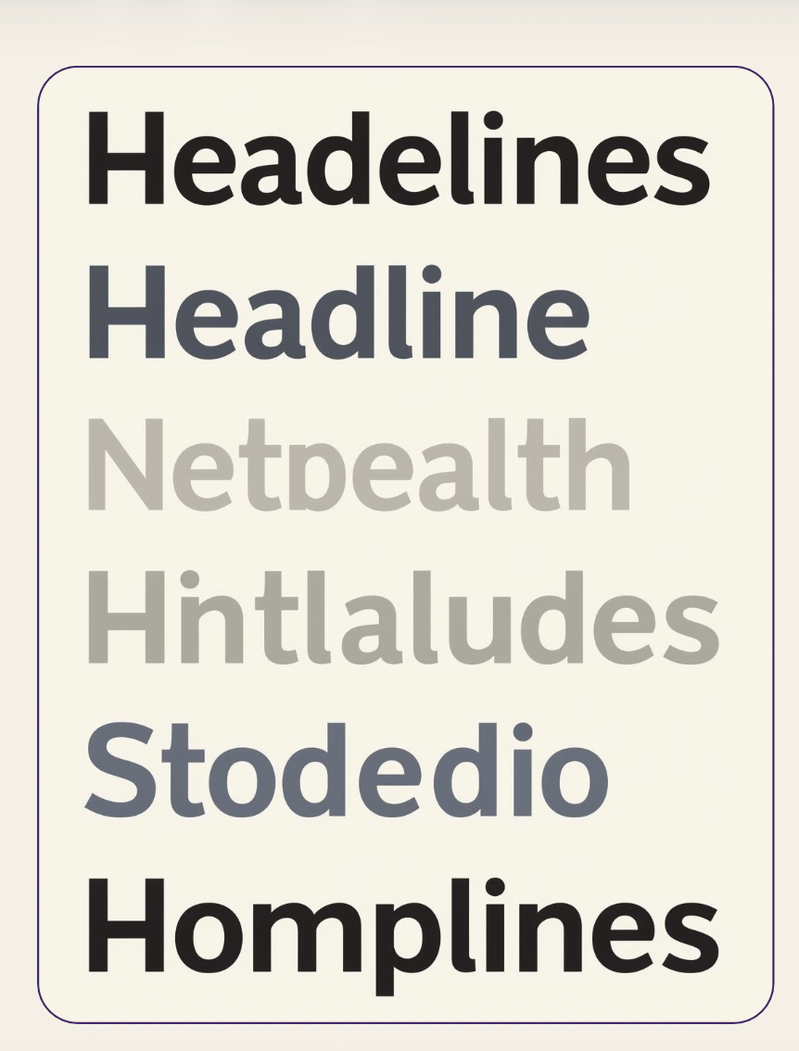

The palette accent colors are a cool blue, peach and coral . the soft gradient system for all buttons will look like:
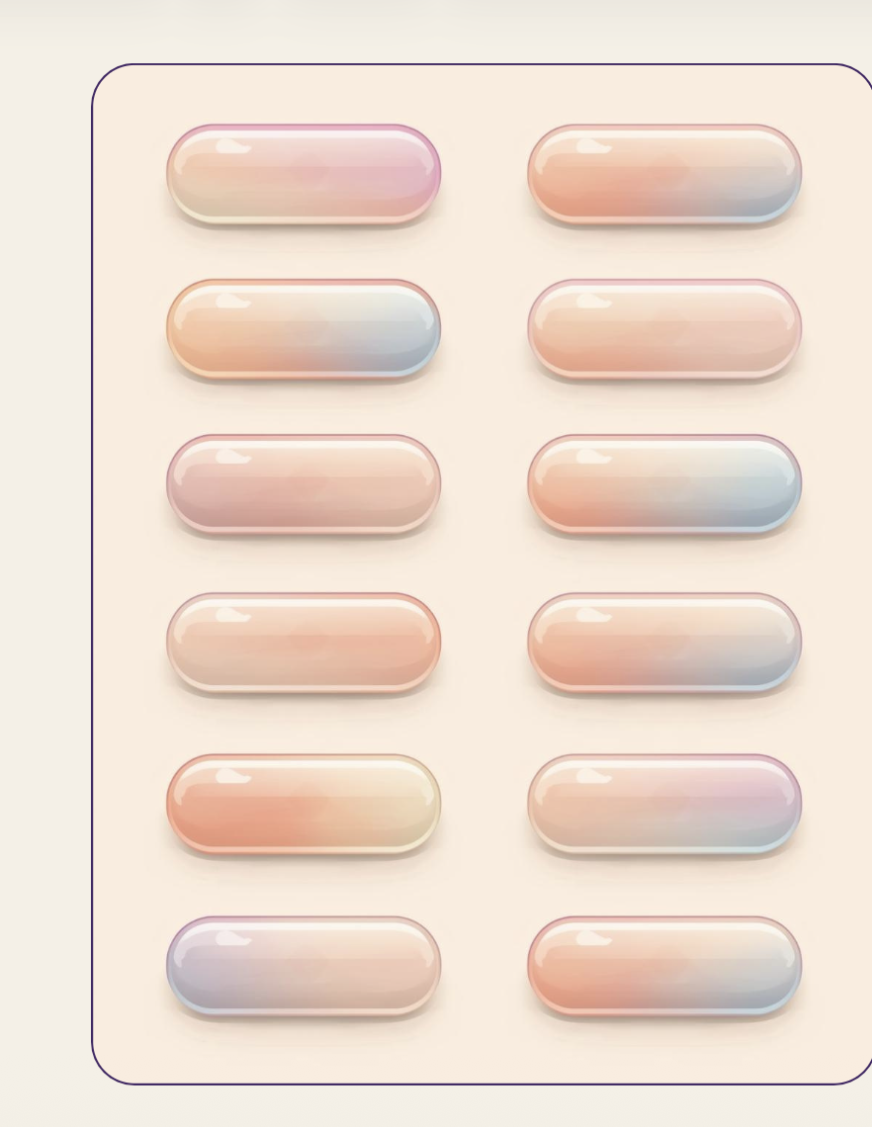

The text font is called Be Vietman

The finalized logo is a thick, playful scribby ‘muse’ with a lowercsae m

When doing a icon for the logo, it’s the m scribbly with line underneath it like below



When writing the name of product with branding, we will have the same font as below, but the M will be uppercase. The 2 colors should be in line with the color palette we identified above.
